Audit Trail - How To Use It

This is a Manhattan associates Audit Trail. It includes the information provided by a JSON file - information like UserId, Updated By, etc. This information can help find those who is in the system, who updated it, and much more.

This documentation is to show how to use this system.

Table of Contents

Download 2

Zip File 2

Github Desktop 2

Things To Know 3

Column Explainations 5

# Download

### Zip File

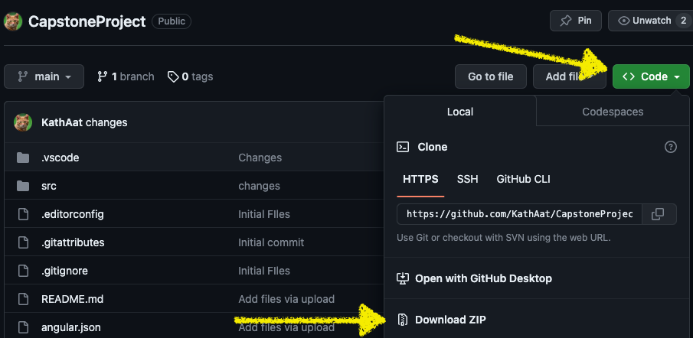

**For the Zip file, once you have it downloaded, open index.html**

### Github Desktop

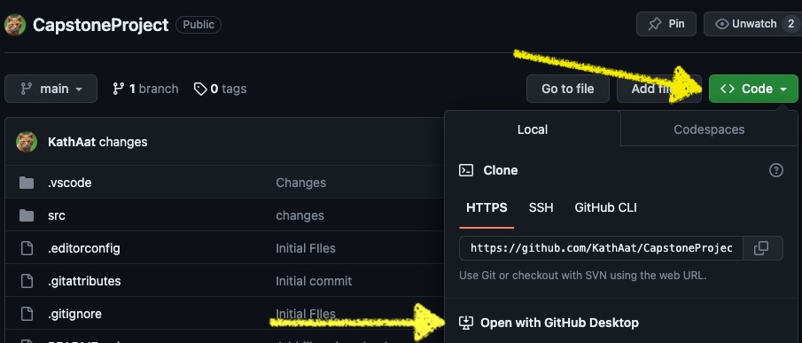

Awesome! Now it has appeared. When you have it open, it’ll look like this:

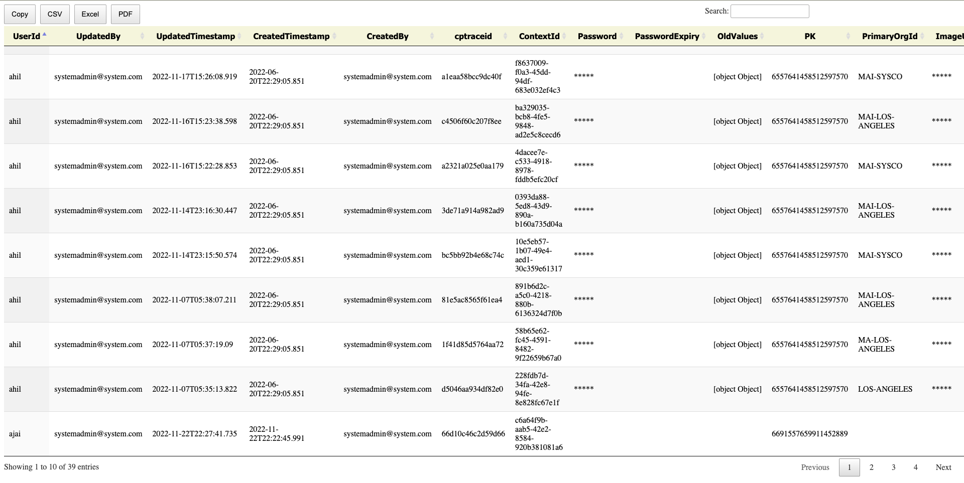

# Things To Know

In order to copy, download it as a pdf, excel file, or csv file, go to the buttons at the top left corner:

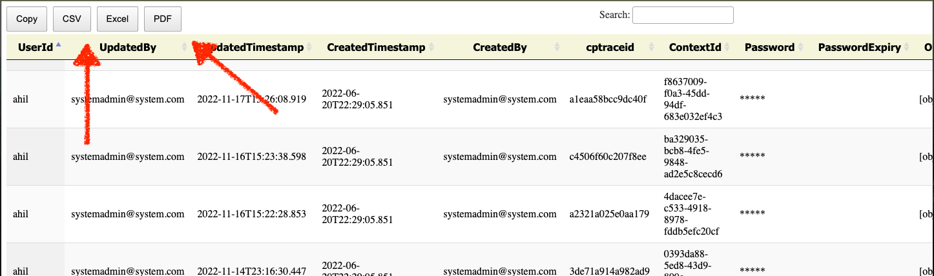

To search go to the search button and it’ll automatically filter:

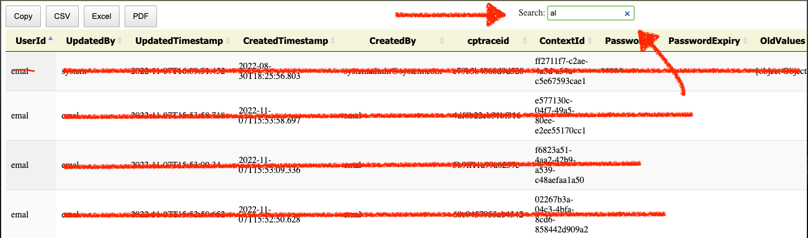

In this example, we searched al and it brought up all UserIds with “al” in it.

To flip through more entries, the buttons to go to the next pages are below. They look like this:



# Column Explainations

Now that we’ve got how to use the UI of it, here’s the column explanations:

| Entity | Description |
| --- | --- |
| UserId | User Id. Can be in email or UserId. Holds all information below |
| Updated By | User who updated the account. Can be shown in email or UserId |
| Updated Timestamp | When it was updated. Format: YYYY-MM-DD:HH-MM-SS |
| Created Timestamp | When it was created. Format: YYYY-MM-DD:HH-MM-SS |
| Created By | User who created the account. Can be shown in email or UserId |
| Cp-Trace-Id | A single request or job that triggered in the application. |
| Context Id | Uniquely identifies an SNMP entity that recognizes an instance of a context with a particular context name |
| Password | Password of the User. Hidden |
| Password Expiry | When the password expires. Can be NULL. |
| Old Values | Old Value before any changes happened |
| PK | Primary Key |
| Primary Org Id | Organization primary ID. |
| Image Url | Images URL. Hidden |